Задание ПБД

Да се проектира и реализира база от данни за БОЛНИЦА, която да съхранява следната информация:

 • Пациент име, ЕГН,

• Лекар - специалност, име, телефон;

• Лечение пациент, лекуващ лекар, дата, продължителност, диагноза

Правила:

• Всеки пациент не може да има повече от едно лечение в едно и също време,

• Всеки лекар има една специалност.

Базата данни трябва да е НОРМАЛИЗИРАНА и да позволява:

1. Въвеждане и корекция на данни

2. Търсене по: пациент, лекар, диагноза

3. Справки за:

• Лечения на пациент, подредени по дата,

• Лечения за лекар, подредени по диагноза,

• Всички лечения за период.

Документацията към реализирания проект трябва да съдържа:

• Задание

• Модели (Oracle Data Modeler)

• SQL команди - DDL, DML

• PL/SQL процедури/тригери/курсори

Модели (Oracle Data Modeler)

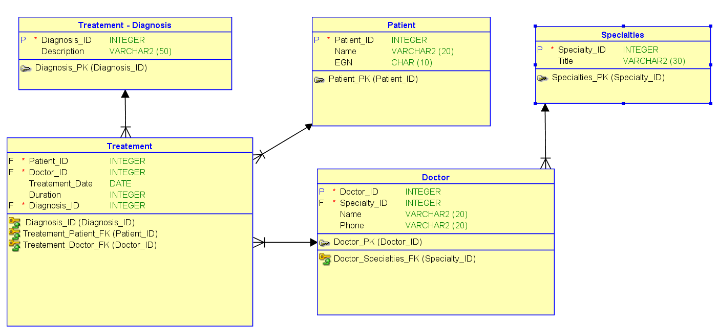

Database_Root/

│

├── Patient/

│ ├── Patient_ID (INT, Primary Key)

│ ├── Name (VARCHAR(20), NOT NULL)

│ ├── EGN (CHAR(10), UNIQUE, NOT NULL)

│

├── Specialties/

│ ├── Specialty_ID (INT, Primary Key)

│ ├── Title (VARCHAR2(30), NOT NULL)

│

├── Doctor/

│ ├── Doctor_ID (INT, Primary Key)

│ ├── Specialty_ID (INT, Foreign Key -> Specialties.Specialty_ID)

│ ├── Name (VARCHAR(20), NOT NULL)

│ ├── Phone (VARCHAR(20))

│

├── Treatment_Diagnosis/

│ ├── Diagnosis_ID (INT, Primary Key)

│ ├── Description (VARCHAR(60), NOT NULL)

│

├── Treatment/

│ ├── Treatment_ID (INT, Primary Key)

│ ├── Patient_ID (INT, Foreign Key -> Patient.Patient_ID)

│ ├── Doctor_ID (INT, Foreign Key -> Doctor.Doctor_ID)

│ ├── Treatment_Date (DATE, NOT NULL)

│ ├── Duration (INT)

│ ├── Diagnosis_ID (INT, Foreign Key -> Treatment_Diagnosis.Diagnosis_ID)

SQL команди - DDL, DML

* DDL

CREATE TABLE Patient (

Patient_ID INT PRIMARY KEY,

Name VARCHAR(20) NOT NULL,

EGN CHAR(10) UNIQUE NOT NULL

);

CREATE TABLE Specialties (

Specialty_ID INT PRIMARY KEY,

Title VARCHAR2(30) NOT NULL

);

CREATE TABLE Doctor (

Doctor_ID INT PRIMARY KEY,

Specialty_ID INT,

Name VARCHAR(20) NOT NULL,

Phone VARCHAR(20),

FOREIGN KEY (Specialty_ID) REFERENCES Specialties(Specialty_ID)

);

CREATE TABLE Treatment_Diagnosis (

Diagnosis_ID INT PRIMARY KEY,

Description VARCHAR(60) NOT NULL

);

CREATE TABLE Treatment (

Treatment_ID INT PRIMARY KEY,

Patient_ID INT,

Doctor_ID INT,

Treatment_Date DATE NOT NULL,

Duration INT,

Diagnosis_ID INT,

FOREIGN KEY (Patient_ID) REFERENCES Patient(Patient_ID),

FOREIGN KEY (Doctor_ID) REFERENCES Doctor(Doctor_ID),

FOREIGN KEY (Diagnosis_ID) REFERENCES Treatment_Diagnosis(Diagnosis_ID)

);

* DML команди - INSERT, UPDATE , DELETE

**Пациенти:**

1. Patient1 (EGN: 100000001)
2. Patient2 (EGN: 100000002)
3. Patient3 (EGN: 100000003)
4. Patient4 (EGN: 100000004)
5. Patient5 (EGN: 100000005)
6. Patient6 (EGN: 100000006)
7. Patient7 (EGN: 100000007)
8. Patient8 (EGN: 100000008)
9. Patient9 (EGN: 100000009)
10. Patient10 (EGN: 1000000010)
11. Patient11 (EGN: 100000011)
12. Patient12 (EGN: 100000012)
13. Patient13 (EGN: 100000013)
14. Patient14 (EGN: 100000014)
15. Patient15 (EGN: 100000015)
16. Patient16 (EGN: 100000016)
17. Patient17 (EGN: 100000017)
18. Patient18 (EGN: 100000018)
19. Patient19 (EGN: 100000019)
20. Patient20 (EGN: 1000000020)

**Специалности:**

1. Specialty1
2. Specialty2
3. Specialty3
4. Specialty4
5. Specialty5
6. Specialty6
7. Specialty7
8. Specialty8
9. Specialty9
10. Specialty10
11. Specialty11
12. Specialty12
13. Specialty13
14. Specialty14
15. Specialty15
16. Specialty16
17. Specialty17
18. Specialty18
19. Specialty19

**Доктори:**

1. Doctor1 (Специалност: Specialty1, Телефон: 0880000001)
2. Doctor2 (Специалност: Specialty2, Телефон: 0880000002)
3. Doctor3 (Специалност: Specialty3, Телефон: 0880000003)
4. Doctor4 (Специалност: Specialty4, Телефон: 0880000004)
5. Doctor5 (Специалност: Specialty5, Телефон: 0880000005)
6. Doctor6 (Специалност: Specialty6, Телефон: 0880000006)
7. Doctor7 (Специалност: Specialty7, Телефон: 0880000007)
8. Doctor8 (Специалност: Specialty8, Телефон: 0880000008)
9. Doctor9 (Специалност: Specialty9, Телефон: 0880000009)
10. Doctor10 (Специалност: Specialty10, Телефон: 0880000010)
11. Doctor11 (Специалност: Specialty11, Телефон: 0880000011)
12. Doctor12 (Специалност: Specialty12, Телефон: 0880000012)
13. Doctor13 (Специалност: Specialty13, Телефон: 0880000013)
14. Doctor14 (Специалност: Specialty14, Телефон: 0880000014)
15. Doctor15 (Специалност: Specialty15, Телефон: 0880000015)
16. Doctor16 (Специалност: Specialty16, Телефон: 0880000016)
17. Doctor17 (Специалност: Specialty17, Телефон: 0880000017)
18. Doctor18 (Специалност: Specialty18, Телефон: 0880000018)
19. Doctor19 (Специалност: Specialty19, Телефон: 0880000019)
20. Doctor20 (Специалност: Specialty20, Телефон: 0880000020)

**Диагнози:**

1. Diagnosis1
2. Diagnosis2
3. Diagnosis3
4. Diagnosis4
5. Diagnosis5
6. Diagnosis6
7. Diagnosis7
8. Diagnosis8
9. Diagnosis9
10. Diagnosis10
11. Diagnosis11
12. Diagnosis12
13. Diagnosis13
14. Diagnosis14
15. Diagnosis15
16. Diagnosis16
17. Diagnosis17
18. Diagnosis18
19. Diagnosis19
20. Diagnosis20

**Лечения:**

1. Patient1 е лекуван от Doctor1 на 2023-01-01 за Diagnosis1 (30 дни).
2. Patient2 е лекуван от Doctor2 на 2023-02-01 за Diagnosis2 (15 дни).
3. Patient3 е лекуван от Doctor3 на 2023-03-01 за Diagnosis3 (20 дни).
4. Patient4 е лекуван от Doctor4 на 2023-04-01 за Diagnosis4 (10 дни).
5. Patient5 е лекуван от Doctor5 на 2023-05-01 за Diagnosis5 (25 дни).
6. Patient6 е лекуван от Doctor6 на 2023-06-01 за Diagnosis6 (18 дни).
7. Patient7 е лекуван от Doctor7 на 2023-07-01 за Diagnosis7 (15 дни).
8. Patient8 е лекуван от Doctor8 на 2023-08-01 за Diagnosis8 (20 дни).
9. Patient9 е лекуван от Doctor9 на 2023-09-01 за Diagnosis9 (10 дни).
10. Patient10 е лекуван от Doctor10 на 2023-10-01 за Diagnosis10 (25 дни).
11. Patient11 е лекуван от Doctor11 на 2023-11-01 за Diagnosis11 (30 дни).
12. Patient12 е лекуван от Doctor12 на 2023-12-01 за Diagnosis12 (15 дни).
13. Patient13 е лекуван от Doctor13 на 2023-11-01 за Diagnosis13 (20 дни).
14. Patient14 е лекуван от Doctor14 на 2023-10-01 за Diagnosis14 (10 дни).
15. Patient15 е лекуван от Doctor15 на 2023-09-01 за Diagnosis15 (25 дни).
16. Patient16 е лекуван от Doctor16 на 2023-08-01 за Diagnosis16 (18 дни).
17. Patient17 е лекуван от Doctor17 на 2023-07-01 за Diagnosis17 (15 дни).
18. Patient18 е лекуван от Doctor18 на 2023-06-01 за Diagnosis18 (20 дни).
19. Patient19 е лекуван от Doctor19 на 2023-05-01 за Diagnosis19 (10 дни).
20. Patient20 е лекуван от Doctor20 на 2023-04-01 за Diagnosis20 (25 дни).
21. Patient1 е лекуван от Doctor2 на 2023-02-01 за Diagnosis2 (30 дни).
22. Patient1 е лекуван от Doctor3 на 2023-03-01 за Diagnosis3 (25 дни).
23. Patient1 е лекуван от Doctor4 на 2023-04-01 за Diagnosis4 (15 дни).
24. Patient1 е лекуван от Doctor5 на 2023-05-01 за Diagnosis5 (30 дни).
25. Patient1 е лекуван от Doctor6 на 2023-06-01 за Diagnosis6 (20 дни).
26. Patient1 е лекуван от Doctor7 на 2023-07-01 за Diagnosis7 (18 дни).
27. Patient1 е лекуван от Doctor8 на 2023-08-01 за Diagnosis8 (25 дни).
28. Patient2 е лекуван от Doctor9 на 2023-02-15 за Diagnosis9 (14 дни).  
    ...

* INSERT

--DATA----------------------------------------------------------------------------------------------------------------------

INSERT INTO Patient (Patient_ID, Name, EGN)

VALUES (1, 'Patient1', '100000001');

INSERT INTO Patient (Patient_ID, Name, EGN)

VALUES (2, 'Patient2', '100000002');

INSERT INTO Patient (Patient_ID, Name, EGN)

VALUES (3, 'Patient3', '100000003');

INSERT INTO Patient (Patient_ID, Name, EGN)

VALUES (4, 'Patient4', '100000004');

INSERT INTO Patient (Patient_ID, Name, EGN)

VALUES (5, 'Patient5', '100000005');

INSERT INTO Patient (Patient_ID, Name, EGN)

VALUES (6, 'Patient6', '100000006');

INSERT INTO Patient (Patient_ID, Name, EGN)

VALUES (7, 'Patient7', '100000007');

INSERT INTO Patient (Patient_ID, Name, EGN)

VALUES (8, 'Patient8', '100000008');

INSERT INTO Patient (Patient_ID, Name, EGN)

VALUES (9, 'Patient9', '100000009');

INSERT INTO Patient (Patient_ID, Name, EGN)

VALUES (10, 'Patient10', '1000000010');

INSERT INTO Patient (Patient_ID, Name, EGN)

VALUES (11, 'Patient11', '100000011');

INSERT INTO Patient (Patient_ID, Name, EGN)

VALUES (12, 'Patient12', '100000012');

INSERT INTO Patient (Patient_ID, Name, EGN)

VALUES (13, 'Patient13', '100000013');

INSERT INTO Patient (Patient_ID, Name, EGN)

VALUES (14, 'Patient14', '100000014');

INSERT INTO Patient (Patient_ID, Name, EGN)

VALUES (15, 'Patient15', '100000015');

INSERT INTO Patient (Patient_ID, Name, EGN)

VALUES (16, 'Patient16', '100000016');

INSERT INTO Patient (Patient_ID, Name, EGN)

VALUES (17, 'Patient17', '100000017');

INSERT INTO Patient (Patient_ID, Name, EGN)

VALUES (18, 'Patient18', '100000018');

INSERT INTO Patient (Patient_ID, Name, EGN)

VALUES (19, 'Patient19', '100000019');

INSERT INTO Patient (Patient_ID, Name, EGN)

VALUES (20, 'Patient20', '1000000020');

INSERT INTO Specialties (Specialty_ID, Title)

VALUES (1, 'Specialty1');

INSERT INTO Specialties (Specialty_ID, Title)

VALUES (2, 'Specialty2');

INSERT INTO Specialties (Specialty_ID, Title)

VALUES (3, 'Specialty3');

INSERT INTO Specialties (Specialty_ID, Title)

VALUES (4, 'Specialty4');

INSERT INTO Specialties (Specialty_ID, Title)

VALUES (5, 'Specialty5');

INSERT INTO Specialties (Specialty_ID, Title)

VALUES (6, 'Specialty6');

INSERT INTO Specialties (Specialty_ID, Title)

VALUES (7, 'Specialty7');

INSERT INTO Specialties (Specialty_ID, Title)

VALUES (8, 'Specialty8');

INSERT INTO Specialties (Specialty_ID, Title)

VALUES (9, 'Specialty9');

INSERT INTO Specialties (Specialty_ID, Title)

VALUES (10, 'Specialty10');

INSERT INTO Specialties (Specialty_ID, Title)

VALUES (11, 'Specialty11');

INSERT INTO Specialties (Specialty_ID, Title)

VALUES (12, 'Specialty12');

INSERT INTO Specialties (Specialty_ID, Title)

VALUES (13, 'Specialty13');

INSERT INTO Specialties (Specialty_ID, Title)

VALUES (14, 'Specialty14');

INSERT INTO Specialties (Specialty_ID, Title)

VALUES (15, 'Specialty15');

INSERT INTO Specialties (Specialty_ID, Title)

VALUES (16, 'Specialty16');

INSERT INTO Specialties (Specialty_ID, Title)

VALUES (17, 'Specialty17');

INSERT INTO Specialties (Specialty_ID, Title)

VALUES (18, 'Specialty18');

INSERT INTO Specialties (Specialty_ID, Title)

VALUES (19, 'Specialty19');

INSERT INTO Specialties (Specialty_ID, Title)

VALUES (20, 'Specialty20');

INSERT INTO Doctor (Doctor_ID, Specialty_ID, Name, Phone)

VALUES (1, 1, 'Doctor1', '0880000001');

INSERT INTO Doctor (Doctor_ID, Specialty_ID, Name, Phone)

VALUES (2, 2, 'Doctor2', '0880000002');

INSERT INTO Doctor (Doctor_ID, Specialty_ID, Name, Phone)

VALUES (3, 3, 'Doctor3', '0880000003');

INSERT INTO Doctor (Doctor_ID, Specialty_ID, Name, Phone)

VALUES (4, 4, 'Doctor4', '0880000004');

INSERT INTO Doctor (Doctor_ID, Specialty_ID, Name, Phone)

VALUES (5, 5, 'Doctor5', '0880000005');

INSERT INTO Doctor (Doctor_ID, Specialty_ID, Name, Phone)

VALUES (6, 6, 'Doctor6', '0880000006');

INSERT INTO Doctor (Doctor_ID, Specialty_ID, Name, Phone)

VALUES (7, 7, 'Doctor7', '0880000007');

INSERT INTO Doctor (Doctor_ID, Specialty_ID, Name, Phone)

VALUES (8, 8, 'Doctor8', '0880000008');

INSERT INTO Doctor (Doctor_ID, Specialty_ID, Name, Phone)

VALUES (9, 9, 'Doctor9', '0880000009');

INSERT INTO Doctor (Doctor_ID, Specialty_ID, Name, Phone)

VALUES (10, 10, 'Doctor10', '0880000010');

INSERT INTO Doctor (Doctor_ID, Specialty_ID, Name, Phone)

VALUES (11, 11, 'Doctor11', '0880000011');

INSERT INTO Doctor (Doctor_ID, Specialty_ID, Name, Phone)

VALUES (12, 12, 'Doctor12', '0880000012');

INSERT INTO Doctor (Doctor_ID, Specialty_ID, Name, Phone)

VALUES (13, 13, 'Doctor13', '0880000013');

INSERT INTO Doctor (Doctor_ID, Specialty_ID, Name, Phone)

VALUES (14, 14, 'Doctor14', '0880000014');

INSERT INTO Doctor (Doctor_ID, Specialty_ID, Name, Phone)

VALUES (15, 15, 'Doctor15', '0880000015');

INSERT INTO Doctor (Doctor_ID, Specialty_ID, Name, Phone)

VALUES (16, 16, 'Doctor16', '0880000016');

INSERT INTO Doctor (Doctor_ID, Specialty_ID, Name, Phone)

VALUES (17, 17, 'Doctor17', '0880000017');

INSERT INTO Doctor (Doctor_ID, Specialty_ID, Name, Phone)

VALUES (18, 18, 'Doctor18', '0880000018');

INSERT INTO Doctor (Doctor_ID, Specialty_ID, Name, Phone)

VALUES (19, 19, 'Doctor19', '0880000019');

INSERT INTO Doctor (Doctor_ID, Specialty_ID, Name, Phone)

VALUES (20, 20, 'Doctor20', '0880000020');

INSERT INTO Treatment_Diagnosis (Diagnosis_ID, Description)

VALUES (1, 'Diagnosis1');

INSERT INTO Treatment_Diagnosis (Diagnosis_ID, Description)

VALUES (2, 'Diagnosis2');

INSERT INTO Treatment_Diagnosis (Diagnosis_ID, Description)

VALUES (3, 'Diagnosis3');

INSERT INTO Treatment_Diagnosis (Diagnosis_ID, Description)

VALUES (4, 'Diagnosis4');

INSERT INTO Treatment_Diagnosis (Diagnosis_ID, Description)

VALUES (5, 'Diagnosis5');

INSERT INTO Treatment_Diagnosis (Diagnosis_ID, Description)

VALUES (6, 'Diagnosis6');

INSERT INTO Treatment_Diagnosis (Diagnosis_ID, Description)

VALUES (7, 'Diagnosis7');

INSERT INTO Treatment_Diagnosis (Diagnosis_ID, Description)

VALUES (8, 'Diagnosis8');

INSERT INTO Treatment_Diagnosis (Diagnosis_ID, Description)

VALUES (9, 'Diagnosis9');

INSERT INTO Treatment_Diagnosis (Diagnosis_ID, Description)

VALUES (10, 'Diagnosis10');

INSERT INTO Treatment_Diagnosis (Diagnosis_ID, Description)

VALUES (11, 'Diagnosis11');

INSERT INTO Treatment_Diagnosis (Diagnosis_ID, Description)

VALUES (12, 'Diagnosis12');

INSERT INTO Treatment_Diagnosis (Diagnosis_ID, Description)

VALUES (13, 'Diagnosis13');

INSERT INTO Treatment_Diagnosis (Diagnosis_ID, Description)

VALUES (14, 'Diagnosis14');

INSERT INTO Treatment_Diagnosis (Diagnosis_ID, Description)

VALUES (15, 'Diagnosis15');

INSERT INTO Treatment_Diagnosis (Diagnosis_ID, Description)

VALUES (16, 'Diagnosis16');

INSERT INTO Treatment_Diagnosis (Diagnosis_ID, Description)

VALUES (17, 'Diagnosis17');

INSERT INTO Treatment_Diagnosis (Diagnosis_ID, Description)

VALUES (18, 'Diagnosis18');

INSERT INTO Treatment_Diagnosis (Diagnosis_ID, Description)

VALUES (19, 'Diagnosis19');

INSERT INTO Treatment_Diagnosis (Diagnosis_ID, Description)

VALUES (20, 'Diagnosis20');

INSERT INTO Treatment (Treatment_ID, Patient_ID, Doctor_ID, Treatment_Date, Duration, Diagnosis_ID)

VALUES (1, 1, 1, TO_DATE('2023-01-01', 'YYYY-MM-DD'), 30, 1);

INSERT INTO Treatment (Treatment_ID, Patient_ID, Doctor_ID, Treatment_Date, Duration, Diagnosis_ID)

VALUES (2, 2, 2, TO_DATE('2023-02-01', 'YYYY-MM-DD'), 15, 2);

INSERT INTO Treatment (Treatment_ID, Patient_ID, Doctor_ID, Treatment_Date, Duration, Diagnosis_ID)

VALUES (3, 3, 3, TO_DATE('2023-03-01', 'YYYY-MM-DD'), 20, 3);

INSERT INTO Treatment (Treatment_ID, Patient_ID, Doctor_ID, Treatment_Date, Duration, Diagnosis_ID)

VALUES (4, 4, 4, TO_DATE('2023-04-01', 'YYYY-MM-DD'), 10, 4);

INSERT INTO Treatment (Treatment_ID, Patient_ID, Doctor_ID, Treatment_Date, Duration, Diagnosis_ID)

VALUES (5, 5, 5, TO_DATE('2023-05-01', 'YYYY-MM-DD'), 25, 5);

INSERT INTO Treatment (Treatment_ID, Patient_ID, Doctor_ID, Treatment_Date, Duration, Diagnosis_ID)

VALUES (6, 6, 6, TO_DATE('2023-06-01', 'YYYY-MM-DD'), 18, 6);

INSERT INTO Treatment (Treatment_ID, Patient_ID, Doctor_ID, Treatment_Date, Duration, Diagnosis_ID)

VALUES (7, 7, 7, TO_DATE('2023-07-01', 'YYYY-MM-DD'), 15, 7);

INSERT INTO Treatment (Treatment_ID, Patient_ID, Doctor_ID, Treatment_Date, Duration, Diagnosis_ID)

VALUES (8, 8, 8, TO_DATE('2023-08-01', 'YYYY-MM-DD'), 20, 8);

INSERT INTO Treatment (Treatment_ID, Patient_ID, Doctor_ID, Treatment_Date, Duration, Diagnosis_ID)

VALUES (9, 9, 9, TO_DATE('2023-09-01', 'YYYY-MM-DD'), 10, 9);

INSERT INTO Treatment (Treatment_ID, Patient_ID, Doctor_ID, Treatment_Date, Duration, Diagnosis_ID)

VALUES (10, 10, 10, TO_DATE('2023-10-01', 'YYYY-MM-DD'), 25, 10);

INSERT INTO Treatment (Treatment_ID, Patient_ID, Doctor_ID, Treatment_Date, Duration, Diagnosis_ID)

VALUES (11, 11, 11, TO_DATE('2023-11-01', 'YYYY-MM-DD'), 30, 11);

INSERT INTO Treatment (Treatment_ID, Patient_ID, Doctor_ID, Treatment_Date, Duration, Diagnosis_ID)

VALUES (12, 12, 12, TO_DATE('2023-12-01', 'YYYY-MM-DD'), 15, 12);

INSERT INTO Treatment (Treatment_ID, Patient_ID, Doctor_ID, Treatment_Date, Duration, Diagnosis_ID)

VALUES (13, 13, 13, TO_DATE('2023-11-01', 'YYYY-MM-DD'), 20, 13);

INSERT INTO Treatment (Treatment_ID, Patient_ID, Doctor_ID, Treatment_Date, Duration, Diagnosis_ID)

VALUES (14, 14, 14, TO_DATE('2023-10-01', 'YYYY-MM-DD'), 10, 14);

INSERT INTO Treatment (Treatment_ID, Patient_ID, Doctor_ID, Treatment_Date, Duration, Diagnosis_ID)

VALUES (15, 15, 15, TO_DATE('2023-09-01', 'YYYY-MM-DD'), 25, 15);

INSERT INTO Treatment (Treatment_ID, Patient_ID, Doctor_ID, Treatment_Date, Duration, Diagnosis_ID)

VALUES (16, 16, 16, TO_DATE('2023-08-01', 'YYYY-MM-DD'), 18, 16);

INSERT INTO Treatment (Treatment_ID, Patient_ID, Doctor_ID, Treatment_Date, Duration, Diagnosis_ID)

VALUES (17, 17, 17, TO_DATE('2023-07-01', 'YYYY-MM-DD'), 15, 17);

INSERT INTO Treatment (Treatment_ID, Patient_ID, Doctor_ID, Treatment_Date, Duration, Diagnosis_ID)

VALUES (18, 18, 18, TO_DATE('2023-06-01', 'YYYY-MM-DD'), 20, 18);

INSERT INTO Treatment (Treatment_ID, Patient_ID, Doctor_ID, Treatment_Date, Duration, Diagnosis_ID)

VALUES (19, 19, 19, TO_DATE('2023-05-01', 'YYYY-MM-DD'), 10, 19);

INSERT INTO Treatment (Treatment_ID, Patient_ID, Doctor_ID, Treatment_Date, Duration, Diagnosis_ID)

VALUES (20, 20, 20, TO_DATE('2023-04-01', 'YYYY-MM-DD'), 25, 20);

INSERT INTO Treatment (Treatment_ID, Patient_ID, Doctor_ID, Treatment_Date, Duration, Diagnosis_ID)

VALUES (21, 1, 2, TO_DATE('2023-02-01', 'YYYY-MM-DD'), 30, 2);

INSERT INTO Treatment (Treatment_ID, Patient_ID, Doctor_ID, Treatment_Date, Duration, Diagnosis_ID)

VALUES (22, 1, 3, TO_DATE('2023-03-01', 'YYYY-MM-DD'), 25, 3);

INSERT INTO Treatment (Treatment_ID, Patient_ID, Doctor_ID, Treatment_Date, Duration, Diagnosis_ID)

VALUES (23, 1, 4, TO_DATE('2023-04-01', 'YYYY-MM-DD'), 15, 4);

INSERT INTO Treatment (Treatment_ID, Patient_ID, Doctor_ID, Treatment_Date, Duration, Diagnosis_ID)

VALUES (24, 1, 5, TO_DATE('2023-05-01', 'YYYY-MM-DD'), 30, 5);

INSERT INTO Treatment (Treatment_ID, Patient_ID, Doctor_ID, Treatment_Date, Duration, Diagnosis_ID)

VALUES (25, 1, 6, TO_DATE('2023-06-01', 'YYYY-MM-DD'), 20, 6);

INSERT INTO Treatment (Treatment_ID, Patient_ID, Doctor_ID, Treatment_Date, Duration, Diagnosis_ID)

VALUES (26, 1, 7, TO_DATE('2023-07-01', 'YYYY-MM-DD'), 18, 7);

INSERT INTO Treatment (Treatment_ID, Patient_ID, Doctor_ID, Treatment_Date, Duration, Diagnosis_ID)

VALUES (27, 1, 8, TO_DATE('2023-08-01', 'YYYY-MM-DD'), 25, 8);

INSERT INTO Treatment (Treatment_ID, Patient_ID, Doctor_ID, Treatment_Date, Duration, Diagnosis_ID)

VALUES (28, 2, 9, TO_DATE('2023-02-15', 'YYYY-MM-DD'), 14, 9);

INSERT INTO Treatment (Treatment_ID, Patient_ID, Doctor_ID, Treatment_Date, Duration, Diagnosis_ID)

VALUES (29, 3, 10, TO_DATE('2023-03-10', 'YYYY-MM-DD'), 21, 10);

INSERT INTO Treatment (Treatment_ID, Patient_ID, Doctor_ID, Treatment_Date, Duration, Diagnosis_ID)

VALUES (30, 4, 11, TO_DATE('2023-04-20', 'YYYY-MM-DD'), 12, 11);

INSERT INTO Treatment (Treatment_ID, Patient_ID, Doctor_ID, Treatment_Date, Duration, Diagnosis_ID)

VALUES (31, 5, 12, TO_DATE('2023-05-25', 'YYYY-MM-DD'), 28, 12);

INSERT INTO Treatment (Treatment_ID, Patient_ID, Doctor_ID, Treatment_Date, Duration, Diagnosis_ID)

VALUES (32, 6, 13, TO_DATE('2023-06-05', 'YYYY-MM-DD'), 17, 13);

INSERT INTO Treatment (Treatment_ID, Patient_ID, Doctor_ID, Treatment_Date, Duration, Diagnosis_ID)

VALUES (33, 7, 1, TO_DATE('2023-07-15', 'YYYY-MM-DD'), 22, 14);

INSERT INTO Treatment (Treatment_ID, Patient_ID, Doctor_ID, Treatment_Date, Duration, Diagnosis_ID)

VALUES (38, 8, 1, TO_DATE('2023-08-25', 'YYYY-MM-DD'), 13, 15);

INSERT INTO Treatment (Treatment_ID, Patient_ID, Doctor_ID, Treatment_Date, Duration, Diagnosis_ID)

VALUES (39, 9, 1, TO_DATE('2023-09-15', 'YYYY-MM-DD'), 19, 16);

INSERT INTO Treatment (Treatment_ID, Patient_ID, Doctor_ID, Treatment_Date, Duration, Diagnosis_ID)

VALUES (40, 10, 1, TO_DATE('2023-10-05', 'YYYY-MM-DD'), 20, 17);

INSERT INTO Treatment (Treatment_ID, Patient_ID, Doctor_ID, Treatment_Date, Duration, Diagnosis_ID)

VALUES (41, 11, 1, TO_DATE('2023-11-10', 'YYYY-MM-DD'), 18, 18);

* UPDATE

--UPDATES-----------------------------------------------------------------------------------------------------------------------

--Patient

UPDATE Patient

SET Name = 'Patient Updated',

EGN = '222000001'

WHERE Patient_ID = 1;

--Doctor

UPDATE Doctor

SET Name = 'Doctor1 Updated',

Phone = '0878888881',

Specialty_ID = 4

WHERE Doctor_ID = 1;

--Specialties

UPDATE Specialties

SET Title = 'Specialty1 Updated'

WHERE Specialty_ID = 1;

--Treatment_Diagnosis

UPDATE Treatment_Diagnosis

SET Description = 'Diagnosis1'

WHERE Diagnosis_ID = 19;

--Treatment

UPDATE Treatment

SET Treatment_Date = TO_DATE('2023-08-01', 'YYYY-MM-DD'),

Duration = 25,

Diagnosis_ID = 4,

Patient_ID = 2,

Doctor_ID = 3

WHERE Treatment_ID = 1;

* SELECT
* Търсене

-- po pacient

SELECT Patient.Name AS pName, Doctor.Name AS Doctor,

Treatment.Treatment_Date AS tDate, Treatment.Duration, Treatment_Diagnosis.Description AS DDescr

FROM Treatment

JOIN Patient ON Treatment.Patient_ID = Patient.Patient_ID

JOIN Doctor ON Treatment.Doctor_ID = Doctor.Doctor_ID

JOIN Treatment_Diagnosis ON Treatment.Diagnosis_ID = Treatment_Diagnosis.Diagnosis_ID

WHERE Patient.Name = 'Patient1'

ORDER BY Treatment.Treatment_Date;

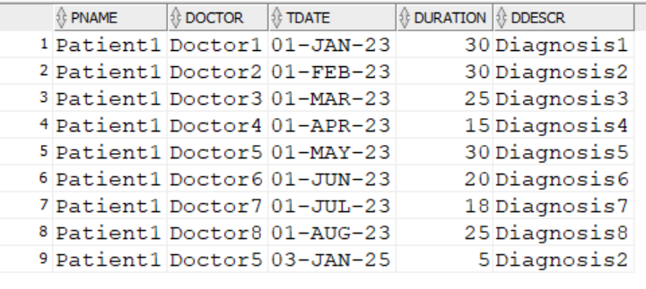

-- po lekar

SELECT Doctor.Name AS dName, Patient.Name AS Patient,

Treatment.Treatment_Date AS tDate, Treatment.Duration, Treatment_Diagnosis.Description AS DDescr

FROM Treatment

JOIN Patient ON Treatment.Patient_ID = Patient.Patient_ID

JOIN Doctor ON Treatment.Doctor_ID = Doctor.Doctor_ID

JOIN Treatment_Diagnosis ON Treatment.Diagnosis_ID = Treatment_Diagnosis.Diagnosis_ID

WHERE Doctor.Name = 'Doctor1'

ORDER BY Treatment.Treatment_Date;

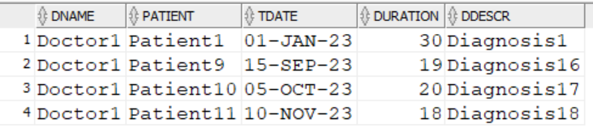

-- po diagnoza

SELECT Treatment_Diagnosis.Description AS Diagnosis, Patient.Name AS Patient_Name, Doctor.Name AS Doctor_Name,

Treatment.Treatment_Date AS tDate, Treatment.Duration

FROM Treatment

JOIN Patient ON Treatment.Patient_ID = Patient.Patient_ID

JOIN Doctor ON Treatment.Doctor_ID = Doctor.Doctor_ID

JOIN Treatment_Diagnosis ON Treatment.Diagnosis_ID = Treatment_Diagnosis.Diagnosis_ID

WHERE Treatment_Diagnosis.Description = 'Diagnosis1'

ORDER BY Treatment.Treatment_Date;

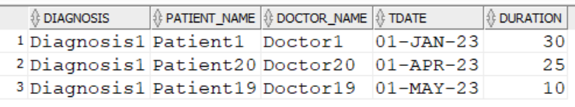

* Справки

-- Lechenie na pacient, podredeni po data

SELECT Treatment_Diagnosis.Description AS Diagnosis, Patient.Name AS Patient_Name, Doctor.Name AS Doctor_Name,

Treatment.Duration, Treatment.Treatment_Date

FROM Treatment

JOIN Patient ON Treatment.Patient_ID = Patient.Patient_ID

JOIN Doctor ON Treatment.Doctor_ID = Doctor.Doctor_ID

JOIN Treatment_Diagnosis ON Treatment.Diagnosis_ID = Treatment_Diagnosis.Diagnosis_ID

WHERE Patient.Name = 'Patient1'

ORDER BY Treatment.Treatment_Date;

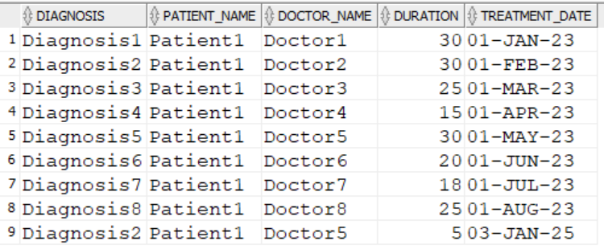

-- lechenie za lekar, podredeni po diagnoza

SELECT Doctor.Name AS Doctor_Name, Patient.Name AS Patient_Name,

Treatment_Diagnosis.Description AS Diagnosis, Treatment.Treatment_Date, Treatment.Duration

FROM Treatment

JOIN Patient ON Treatment.Patient_ID = Patient.Patient_ID

JOIN Doctor ON Treatment.Doctor_ID = Doctor.Doctor_ID

JOIN Treatment_Diagnosis ON Treatment.Diagnosis_ID = Treatment_Diagnosis.Diagnosis_ID

WHERE Doctor.Name = 'Doctor1'

ORDER BY Treatment_Diagnosis.Description;

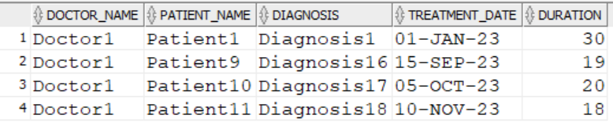

--Vsichki lecheniq za perioda

SELECT Patient.Name AS Patient_Name, Doctor.Name AS Doctor_Name,

Treatment_Diagnosis.Description AS Diagnosis, Treatment.Treatment_Date, Treatment.Duration

FROM Treatment

JOIN Patient ON Treatment.Patient_ID = Patient.Patient_ID

JOIN Doctor ON Treatment.Doctor_ID = Doctor.Doctor_ID

JOIN Treatment_Diagnosis ON Treatment.Diagnosis_ID = Treatment_Diagnosis.Diagnosis_ID

WHERE Treatment.Treatment_Date BETWEEN TO_DATE('2023-03-01', 'YYYY-MM-DD') AND TO_DATE('2023-12-31', 'YYYY-MM-DD')

ORDER BY Treatment.Treatment_Date;

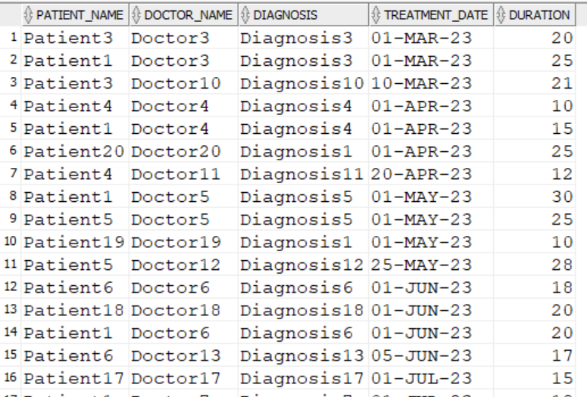

* PL/SQL процедури/тригери/курсори
* Процедури

--PACIENT---------------------------------------------------------->

--add

CREATE OR REPLACE PROCEDURE Add_Patient(

p_Patient_ID IN INT,

p_Name IN VARCHAR,

p_EGN IN CHAR

)

IS

BEGIN

INSERT INTO Patient (Patient_ID, Name, EGN)

VALUES (p_Patient_ID, p_Name, p_EGN);

END;

/

--update

CREATE OR REPLACE PROCEDURE Update_Patient(

p_Patient_ID IN INT,

p_Name IN VARCHAR,

p_EGN IN CHAR

)

IS

BEGIN

UPDATE Patient

SET Name = p_Name,

EGN = p_EGN

WHERE Patient_ID = p_Patient_ID;

END;

/

--delete

CREATE OR REPLACE PROCEDURE Delete_Patient(

p_Patient_ID IN INT

)

IS

BEGIN

DELETE FROM Patient

WHERE Patient_ID = p_Patient_ID;

END;

/

--LEKAR---------------------------------------------------------->

--add

CREATE OR REPLACE PROCEDURE Add_Doctor(

p_Doctor_ID IN INT,

p_Specialty_ID IN INT,

p_Name IN VARCHAR,

p_Phone IN VARCHAR

)

IS

BEGIN

INSERT INTO Doctor (Doctor_ID, Specialty_ID, Name, Phone)

VALUES (p_Doctor_ID, p_Specialty_ID, p_Name, p_Phone);

END;

/

--update

CREATE OR REPLACE PROCEDURE Update_Doctor(

p_Doctor_ID IN INT,

p_Specialty_ID IN INT,

p_Name IN VARCHAR,

p_Phone IN VARCHAR

)

IS

BEGIN

UPDATE Doctor

SET Specialty_ID = p_Specialty_ID,

Name = p_Name,

Phone = p_Phone

WHERE Doctor_ID = p_Doctor_ID;

END;

/

--delete

CREATE OR REPLACE PROCEDURE Delete_Doctor(

p_Doctor_ID IN INT

)

IS

BEGIN

DELETE FROM Doctor

WHERE Doctor_ID = p_Doctor_ID;

END;

/

--LECHENIE---------------------------------------------------------->

--add

CREATE OR REPLACE PROCEDURE Add_Treatment(

p_Treatment_ID IN INT,

p_Patient_ID IN INT,

p_Doctor_ID IN INT,

p_Treatment_Date IN DATE,

p_Duration IN INT,

p_Diagnosis_ID IN INT

)

IS

BEGIN

INSERT INTO Treatment (Treatment_ID, Patient_ID, Doctor_ID, Treatment_Date, Duration, Diagnosis_ID)

VALUES (p_Treatment_ID, p_Patient_ID, p_Doctor_ID, p_Treatment_Date, p_Duration, p_Diagnosis_ID);

END;

/

--update

CREATE OR REPLACE PROCEDURE Update_Treatment(

p_Treatment_ID IN INT,

p_Patient_ID IN INT,

p_Doctor_ID IN INT,

p_Treatment_Date IN DATE,

p_Duration IN INT,

p_Diagnosis_ID IN INT

)

IS

BEGIN

UPDATE Treatment

SET Patient_ID = p_Patient_ID,

Doctor_ID = p_Doctor_ID,

Treatment_Date = p_Treatment_Date,

Duration = p_Duration,

Diagnosis_ID = p_Diagnosis_ID

WHERE Treatment_ID = p_Treatment_ID;

END;

/

--delete

CREATE OR REPLACE PROCEDURE Delete_Treatment(

p_Treatment_ID IN INT

)

IS

BEGIN

DELETE FROM Treatment

WHERE Treatment_ID = p_Treatment_ID;

END;

/

* Тригери

Търсения  
  
Справки

--PATIENT ID---------------------------------------------------------->

CREATE OR REPLACE TRIGGER trg_patient_id

BEFORE INSERT ON Patient

FOR EACH ROW

BEGIN

SELECT NVL(MAX(Patient_ID), 0) + 1 INTO :NEW.Patient_ID

FROM Patient;

END;

--DOCTOR ID---------------------------------------------------------->

CREATE OR REPLACE TRIGGER trg_doctor_id

BEFORE INSERT ON Doctor

FOR EACH ROW

BEGIN

SELECT NVL(MAX(Doctor_ID), 0) + 1 INTO :NEW.Doctor_ID

FROM Doctor;

END;

--TREATEMENT ID---------------------------------------------------------->

CREATE OR REPLACE TRIGGER trg_treatment_id

BEFORE INSERT ON Treatment

FOR EACH ROW

BEGIN

SELECT NVL(MAX(Treatment_ID), 0) + 1 INTO :NEW.Treatment_ID

FROM Treatment;

END;

IF v_specialty_exists = 0 THEN

RAISE_APPLICATION_ERROR(-20004, 'ERROR! Specialty not exist!');

END IF;

END;

/  
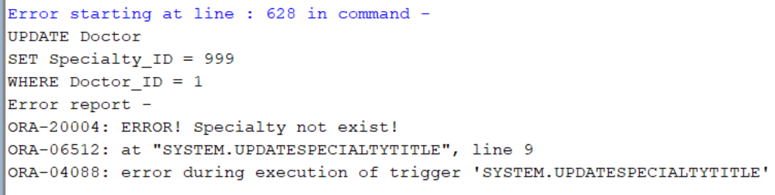

--Dublirane na lechenie na pacient------------------------------------------------------------>

CREATE OR REPLACE TRIGGER CheckPatientTreatmentOverlap

BEFORE INSERT OR UPDATE ON Treatment

FOR EACH ROW

DECLARE

v_count INT;

BEGIN

SELECT COUNT(*)

INTO v_count

FROM Treatment

WHERE Patient_ID = :NEW.Patient_ID

AND Treatment_Date <= :NEW.Treatment_Date + :NEW.Duration

AND Treatment_Date + Duration >= :NEW.Treatment_Date;

IF v_count > 0 THEN

RAISE_APPLICATION_ERROR(-20001, 'Error! Patient already having appointment!');

END IF;

END;

/  
--Пациент1 има лечение от 20-ти декември 2023 г. за 30 дена  
--Случай 1: от 18-ти Декември 2023 г. за 5 дена

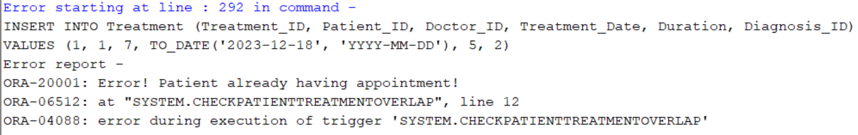

--Случай 2: от 20-ти Декември 2023 г. за 30 дена

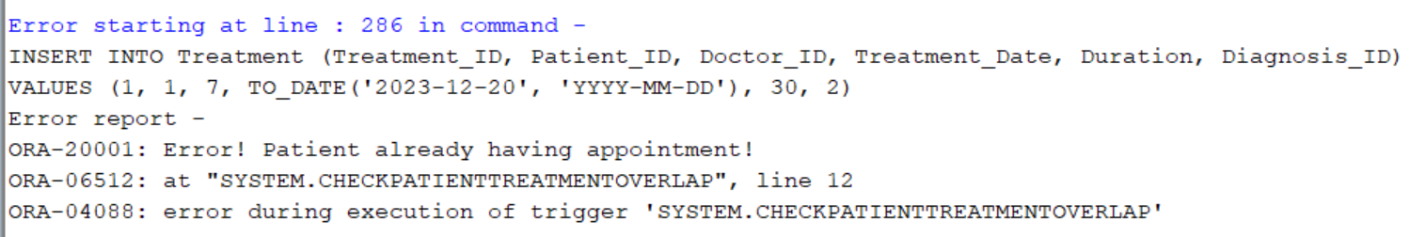

--Случай 3: от 30-ти Декември 2023 г. за 10 дена

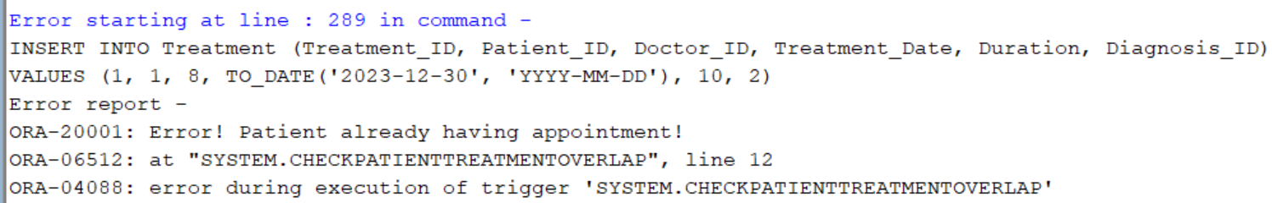

--DUBLIRANE NA DOKTOR NA RAZLICHI LECHENIQ PO EDNO I SUSHTO VREME---------------------------------------->

CREATE OR REPLACE TRIGGER CheckDoctorTreatmentOverlap

BEFORE INSERT OR UPDATE ON Treatment

FOR EACH ROW

DECLARE

v_count INT;

BEGIN

SELECT COUNT(*)

INTO v_count

FROM Treatment

WHERE Doctor_ID = :NEW.Doctor_ID

AND Treatment_Date <= :NEW.Treatment_Date + :NEW.Duration

AND Treatment_Date + Duration >= :NEW.Treatment_Date;

IF v_count > 0 THEN

RAISE_APPLICATION_ERROR(-20002, 'ERROR! Doctor is busy!');

END IF;

END;

/

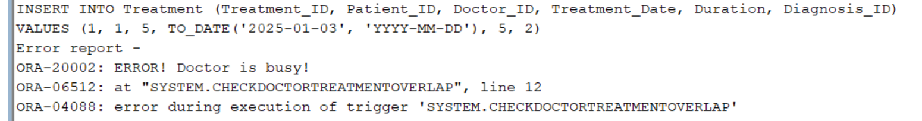

* Курсори

--Търсенията---------------------------------------------------------------------------------------------------------------

--TURSENIQ--------------------------------------------------------------

--po ime na pacient

CREATE OR REPLACE PROCEDURE Get_Treatments_By_Patient_Name (

p_Patient_Name IN VARCHAR2

) AS

CURSOR treatment_cursor IS

SELECT p.name AS patient_name,

d.name AS doctor_name,

t.treatment_date AS treatment_date,

t.duration AS treatment_duration,

td.description AS diagnosis_description

FROM Treatment t

JOIN Patient p ON t.patient_id = p.patient_id

JOIN Doctor d ON t.doctor_id = d.doctor_id

JOIN Treatment_Diagnosis td ON t.diagnosis_id = td.diagnosis_id

WHERE LOWER(p.name) LIKE '%' || LOWER(p_Patient_Name) || '%'

ORDER BY t.treatment_date;

v_patient_name Patient.Name%TYPE;

v_doctor_name Doctor.Name%TYPE;

v_treatment_date Treatment.Treatment_Date%TYPE;

v_treatment_duration Treatment.Duration%TYPE;

v_diagnosis_description Treatment_Diagnosis.Description%TYPE;

BEGIN

OPEN treatment_cursor;

LOOP

FETCH treatment_cursor INTO v_patient_name, v_doctor_name, v_treatment_date, v_treatment_duration, v_diagnosis_description;

EXIT WHEN treatment_cursor%NOTFOUND;

DBMS_OUTPUT.PUT_LINE('Patient: ' || v_patient_name ||

', Doctor: ' || v_doctor_name ||

', Date: ' || v_treatment_date ||

', Duration: ' || v_treatment_duration ||

' days, Diagnosis: ' || v_diagnosis_description);

END LOOP;

CLOSE treatment_cursor;

END;

EXEC Get_Treatments_By_Patient_Name('Patient12');

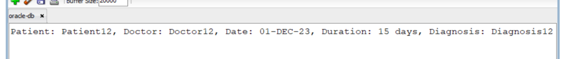

--po lekar

CREATE OR REPLACE PROCEDURE Get_Treatments_By_Doctor_Name (

p_Doctor_Name IN VARCHAR2

) AS

CURSOR treatment_cursor IS

SELECT d.name AS doctor_name,

p.name AS patient_name,

t.treatment_date AS treatment_date,

t.duration AS treatment_duration,

td.description AS diagnosis_description

FROM Treatment t

JOIN Patient p ON t.patient_id = p.patient_id

JOIN Doctor d ON t.doctor_id = d.doctor_id

JOIN Treatment_Diagnosis td ON t.diagnosis_id = td.diagnosis_id

WHERE LOWER(d.name) LIKE '%' || LOWER(p_Doctor_Name) || '%'

ORDER BY t.treatment_date;

v_doctor_name Doctor.Name%TYPE;

v_patient_name Patient.Name%TYPE;

v_treatment_date Treatment.Treatment_Date%TYPE;

v_treatment_duration Treatment.Duration%TYPE;

v_diagnosis_description Treatment_Diagnosis.Description%TYPE;

BEGIN

OPEN treatment_cursor;

LOOP

FETCH treatment_cursor INTO v_doctor_name, v_patient_name, v_treatment_date, v_treatment_duration, v_diagnosis_description;

EXIT WHEN treatment_cursor%NOTFOUND;

DBMS_OUTPUT.PUT_LINE('Doctor: ' || v_doctor_name ||

', Patient: ' || v_patient_name ||

', Date: ' || v_treatment_date ||

', Duration: ' || v_treatment_duration ||

' days, Diagnosis: ' || v_diagnosis_description);

END LOOP;

CLOSE treatment_cursor;

END;

EXEC Get_Treatments_By_Doctor_Name('Doctor15');

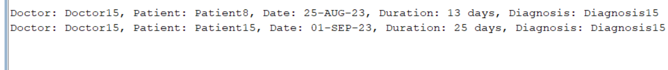

--po lechenie

CREATE OR REPLACE PROCEDURE Get_Treatments_By_Diagnosis (

p_Diagnosis_Name IN VARCHAR2

) AS

CURSOR treatment_cursor IS

SELECT d.name AS doctor_name,

p.name AS patient_name,

t.treatment_date AS treatment_date,

t.duration AS treatment_duration,

td.description AS diagnosis_description

FROM Treatment t

JOIN Patient p ON t.patient_id = p.patient_id

JOIN Doctor d ON t.doctor_id = d.doctor_id

JOIN Treatment_Diagnosis td ON t.diagnosis_id = td.diagnosis_id

WHERE LOWER(td.description) LIKE '%' || LOWER(p_Diagnosis_Name) || '%'

ORDER BY t.treatment_date;

v_doctor_name Doctor.Name%TYPE;

v_patient_name Patient.Name%TYPE;

v_treatment_date Treatment.Treatment_Date%TYPE;

v_treatment_duration Treatment.Duration%TYPE;

v_diagnosis_description Treatment_Diagnosis.Description%TYPE;

BEGIN

OPEN treatment_cursor;

LOOP

FETCH treatment_cursor INTO v_doctor_name, v_patient_name, v_treatment_date, v_treatment_duration, v_diagnosis_description;

EXIT WHEN treatment_cursor%NOTFOUND;

DBMS_OUTPUT.PUT_LINE('Diagnosis: ' || v_diagnosis_description ||

', Doctor: ' || v_doctor_name ||

', Patient: ' || v_patient_name ||

', Date: ' || v_treatment_date ||

', Duration: ' || v_treatment_duration ||

' days');

END LOOP;

CLOSE treatment_cursor;

END;

/

EXEC Get_Treatments_By_Diagnosis('Diagnosis11');

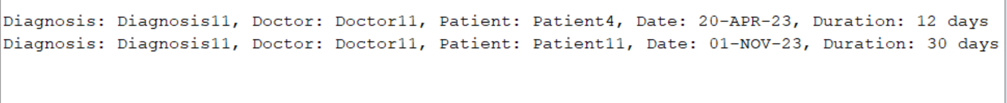

--Справки----------------------------------------------------------------------------------

--lechenie po EGN---------------------------------------->

CREATE OR REPLACE PROCEDURE Get_Treatments_By_Patient (

p_EGN IN CHAR

) AS

CURSOR treatment_cursor IS

SELECT t.treatment_date, t.duration, p.egn, p.name, td.description, d.name

FROM Treatment t

JOIN Patient p ON t.patient_id = p.patient_id

JOIN Treatment_Diagnosis td ON t.diagnosis_id = td.diagnosis_id

JOIN Doctor d ON t.doctor_id = d.doctor_id

WHERE p.egn = p_EGN

ORDER BY t.treatment_date;

v_treatment_date Treatment.Treatment_Date%TYPE;

v_duration Treatment.Duration%TYPE;

v_patient_egn Patient.EGN%TYPE;

v_patient_name Patient.Name%TYPE;

v_description Treatment_Diagnosis.Description%TYPE;

v_doctor_name Doctor.Name%TYPE;

BEGIN

OPEN treatment_cursor;

LOOP

FETCH treatment_cursor INTO v_treatment_date, v_duration, v_patient_egn, v_patient_name, v_description, v_doctor_name;

EXIT WHEN treatment_cursor%NOTFOUND;

DBMS_OUTPUT.PUT_LINE('Date: ' || v_treatment_date ||

', Patient EGN: ' || v_patient_egn ||

', Patient Name: ' || v_patient_name ||

', Duration: ' || v_duration ||

', Diagnosis: ' || v_description ||

', Doctor: ' || v_doctor_name);

END LOOP;

CLOSE treatment_cursor;

END;  
EXEC Get_Treatments_By_Patient('100000004');

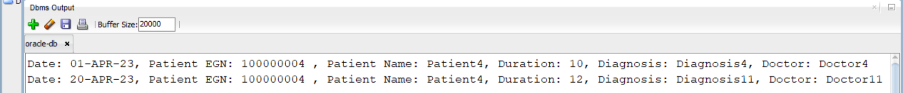

--Diagnosis po Doctor ---------------------------------------->

CREATE OR REPLACE PROCEDURE Get_Diagnoses_By_Doctor (

p_Doctor_Name IN VARCHAR2

) AS

CURSOR diagnose_cursor IS

SELECT d.name AS doctor_name,

p.name AS patient_name,

t.duration AS treatment_duration,

td.description AS diagnosis_description,

t.treatment_date AS treatment_date

FROM Treatment t

JOIN Treatment_Diagnosis td ON t.diagnosis_id = td.diagnosis_id

JOIN Doctor d ON t.doctor_id = d.doctor_id

JOIN Patient p ON t.patient_id = p.patient_id

WHERE LOWER(d.name) LIKE '%' || LOWER(p_Doctor_Name) || '%'

ORDER BY t.treatment_date;

v_doctor_name Doctor.Name%TYPE;

v_patient_name Patient.Name%TYPE;

v_treatment_duration Treatment.Duration%TYPE;

v_description Treatment_Diagnosis.Description%TYPE;

v_treatment_date Treatment.Treatment_Date%TYPE;

BEGIN

OPEN diagnose_cursor;

LOOP

FETCH diagnose_cursor INTO v_doctor_name, v_patient_name, v_treatment_duration, v_description, v_treatment_date;

EXIT WHEN diagnose_cursor%NOTFOUND;

DBMS_OUTPUT.PUT_LINE('Doctor: ' || v_doctor_name ||

', Patient: ' || v_patient_name ||

', Duration: ' || v_treatment_duration ||

' days, Diagnosis: ' || v_description ||

', Date: ' || v_treatment_date);

END LOOP;

CLOSE diagnose_cursor;

EXCEPTION

WHEN OTHERS THEN

DBMS_OUTPUT.PUT_LINE('Error: ' || SQLERRM);

END;

EXEC Get_Diagnoses_By_Doctor('Doctor20');

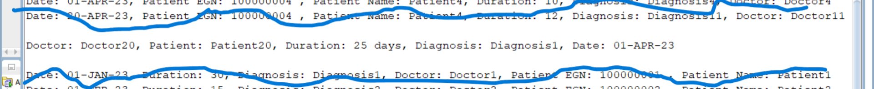

--Start_Date i End_Date na Treatement ---------------------------------------->

CREATE OR REPLACE PROCEDURE Get_Treatments_By_Date (

p_Start_Date IN DATE,

p_End_Date IN DATE

) AS

CURSOR treatment_cursor IS

SELECT t.treatment_id, t.treatment_date, t.duration, td.description, d.name, p.egn, p.name

FROM Treatment t

JOIN Treatment_Diagnosis td ON t.diagnosis_id = td.diagnosis_id

JOIN Doctor d ON t.doctor_id = d.doctor_id

JOIN Patient p ON t.patient_id = p.patient_id

WHERE t.treatment_date BETWEEN p_Start_Date AND p_End_Date

ORDER BY t.treatment_date;

v_treatment_id Treatment.Treatment_ID%TYPE;

v_treatment_date Treatment.Treatment_Date%TYPE;

v_duration Treatment.Duration%TYPE;

v_description Treatment_Diagnosis.Description%TYPE;

v_doctor_name Doctor.Name%TYPE;

v_patient_egn Patient.EGN%TYPE;

v_patient_name Patient.Name%TYPE;

BEGIN

OPEN treatment_cursor;

LOOP

FETCH treatment_cursor INTO v_treatment_id, v_treatment_date, v_duration, v_description, v_doctor_name, v_patient_egn, v_patient_name;

EXIT WHEN treatment_cursor%NOTFOUND;

DBMS_OUTPUT.PUT_LINE('Date: ' || v_treatment_date ||

', Duration: ' || v_duration ||

', Diagnosis: ' || v_description ||

', Doctor: ' || v_doctor_name ||

', Patient EGN: ' || v_patient_egn ||

', Patient Name: ' || v_patient_name);

END LOOP;

CLOSE treatment_cursor;

END;

EXEC Get_Treatments_By_Date(TO_DATE('2023-01-01', 'YYYY-MM-DD'), TO_DATE('2023-10-01', 'YYYY-MM-DD'));

